Annual report 2021-2022

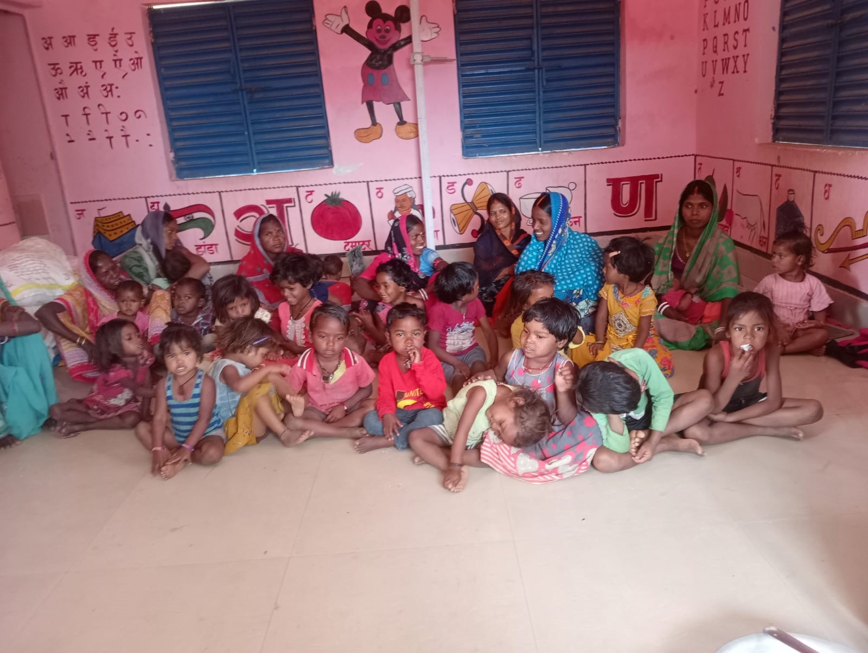
LOKDEEP
College Road, Madhupur, 815353
District-Deoghar, Jharkhand,India
Mobile No.-9431132968
E-mail-lokdeeporg@gmail.com

From the Desk of the Director -cum- Secretary
This annual report is not only a record of achievement for us, but also each work completed is associated in our memory with faces to which we brought smiles. InRaneshwar block of Dumka major activities are related with women empowerment and micro finance, in Devipur block of Deoghar on RCH and safe motherhood, in Narayanpur block of Jamtara on local governance, Panchayati Raj institutions and in Madhupur block of Deoghar on Natural resource management.
Social Mobilization is the key Component of LOKDEEP. Through the action LOKDEEP wants to establish a permanent forum of the people at village level for planning, execution and monitoring its development programs for a longer period. This basic strategy enforces to sustain the program.
This year we have been able to further strengthen our micro-finance program and increase the participation of women in development process.However, the organization has faced paucity of funds and needs additional support from donors and development agencies.

We would like to thank our donor organizations for their full support in our endeavor. We express our sincere thanks to the volunteers, local community and associated local experts who helped the organization to serve in a better way. Last but not least I would like to thank the Lok Deep project and office staff, advisors and members of the Governing body for their devoted attention to guide our team members from time to time especially in the critical situations. We are also grateful to SPWD, Ranchi, Abhivyakti Foundation, Giridih and individual Consultants for their technical support and cooperation.
Please feel free to express your opinion and suggestions to improve our efforts.
Let us join hands together.

Pradip Kumar Singh
Director

Madhupur,20.07.2021

Name of the Organization | Lokdeep
Address | College Road, Madhupur  District Deoghar, PIN – 815353
Legal Status | Registered Under Socities Registration Act 1860(Act XXII)with Govt. Of Jharkhand.  Registration No. REGd.-342 dated 21st July.12A of Income Tax Act,1961.  Regd.Under FCRA, 1976.
Contact person | Mr.Pradip Kumar Singh
Registered Address: | Collage Road Madhupur, district- Deoghar  Jharkhand, India
Our Bankers | Allahabad Bank, Madhupur  Deoghar.

Background Information
The organization emerged as devolutionary concept to localize the development initiatives. In 1987 construction of Burhai dam some social organizations came forward where the founders of Lok Deep joined the movement and further participated in the mass campaigns for community based natural resource management. In the process we came in contact with Late Binay Chandra Singh, an ex-Ary,a renowned social worker and environmentalist of the area who motivated the team for social work. The founders were taking up full-fledged activities. The devolutionary approach of Badlao encouraged key leaders to take up own initiatives in the area from where the organization came into existence.

Our Mission
We are committed to establish effective and mutually beneficial partnerships among NGOS, farmer organizations and agricultural research centers in order to mobilize research to benefit the rural poor in less favorable environments for social justice, sustainable development and human rights. We are also committed to the dissemination of information and promotion of sustainable development initiatives, in response to the needs of underrepresented and marginalized sectors of society.
Lok Deep, is an organization which fully believes in all around development of the areas. Specific role of Lok Deep in rural development are as follows:
* To supplement government effort
* To mobilize and sensitize the people at the village level.
* To set an example to activate the delivery system.
* To disseminate information to make communities as self- reliant as possible
* To show how village and indigenous resources could be used.
* To train of community leader and Local resource person.
* To mobilize local financial resources, and
* To mobilize and organize the poor.

Values / guiding principles
Democratic process, team work, transparency, accountability and social responsibility are the guiding principles of Lok Deep.
We believe that community has the power to address its own problems and someone has to take initiatives to trigger off. Poverty comes from the social stigmas and the community has power to overcome poverty where organization, govt. and other agencies could facilitate the development process. Undemanded aids without involving the local communities’ causemuch dependency on external sources whereas Lok Deep has specific focus to build up local resources and further develop the social regulations to strengthen the development process.
Philosophy of Development
The development philosophy of Lok Deep is based on Maxim “your problems; your solution” to encourage self-help approach among disadvantaged community. To enable the decision-making abilities among these venerable communities the organization follows a systematic path approach:
- Community organization
- Capacity building
- Facilitation for technical, financial and marketing linkages & information sharing.
- Establishment of pilot models & replication
- Policy advocacy

Major activities of Lok Deep during the period 2021-22

Health Awareness Campaign in Karmatar Block:
Lokdeep organized a health awareness campaign. Vitamin Angel, an organization from the USA, provide essential medicines and supplements to Lokdeep.We conducted interactive workshops and did health check-ups andfor finding the people withworming and Vitamin A deficiency. This initiative aimed at addressing common health issues among children and women, promoting overall well-being.

Key Objectives:
Our primaryobjective in organizing the health awareness campaign was to educate and inform the community about the importance of primary health services. By raising awareness, we aimed to empower individuals to make informed decisions about their health, access available services, and promote a proactive approach to well-being.
This activity Increased awareness about the significance of regular health check-ups and preventive care.Improved understanding among the community about the benefits of primary health services.Direct health benefits to 5000 children and 300 women through deworming tablets and Vitamin A supplements.

Special Coaching Center for Boys and Girls

- Lok Deep established the coaching Centre in Patrudih village,Posta panchayat Jamtara for the students of marginalized class who don’t get the opportunity to study due to some financial issues. The center is designed to be self-reliant, driven by active community participation, aiming to bridge educational gaps, empower students, and foster an environment conducive to holistic learning. 30-35 students are there studying in the coaching Centre.
Key Objectives:
- Providing Quality Education: The center is dedicated to offering high-quality education to students facing financial constraints, ensuring they receive the same opportunities as their more privileged peers.

- Bridging Educational Gaps: Our objective is to bridge educational disparities by providing additional support and resources to students, enabling them to thrive in the mainstream education system.
- Promoting Community Participation: We aim to actively involve the community in the education of their children, fostering a sense of ownership and shared responsibility for the students' academic journey.

- Empowering Students: Beyond academics, the coaching center seeks to empower students by imparting skills, building confidence, and enhancing overall personality traits to help them overcome socio-economic challenges.

- Holistic Learning Environment: We strive to create an environment conducive to holistic learning, going beyond traditional teaching methods to support the overall development of students.

Impact:
This activity Increased community involvement and participation in the education of their children. Witnessed positive changes in students' confidence, communication skills, and overall personality development. Demonstrated a significant improvement in the academic performance of students attending the coaching center.

Prevention of Child Marriage.
Lok Deep is a state level active member of Girls Not Brides organization.They are working to address the critical issue of child marriage in Birajpur panchayat in Jamtara district.This partnership aims to contribute to the prevention of child marriages and the overall enhancement of child protection within the community.We organize adolescent girls meeting and create awareness among them.
Key Objectives
- Raising Awareness:
Increase awareness about the negative impacts of child marriage within thecommunity.

- Strengthening Child Protection Community:
Enhance the capacity of the child protection community to identify, prevent, and respond to cases of child marriage.

- Reducing Incidence of Child Marriage:
Achieve a measurable reduction in the number of reported cases of child marriage within the community.
- Empowering Girls:
Enable girls to access education and skill development opportunities, leading to increased confidence and independence.

- Community Vigilance and Protection:
Strengthen child protection mechanisms within the community.

Impact:
  - 5 Adolescent club was formed at Panchayat level.
  - Notable reduction in reportedcases, indicating successful prevention efforts.
  - Increased awareness resulting in a positive shift in community attitudes towards early marriages.
  - Girls gaining access to education and skill development opportunities, fostering confidence and independence.
  - Positive changes in societal perceptions about the role and potential of girls.

Women EmpowermentthroughSelf Help Approach
Lok Deep believes that community empowerment with rights-based approach leads to sustainable development. Therefore, we emphasize to make community rich in information through our community educative program, so that they could address their social poverty, initiate for their economic upliftment and realize their civic rights with integrated development approach. Our community empowerment program is much more focused on Dalit and most backward women. Under this program sector, we focus on the following components:
- Formation of informal community institutions (women SHGs, SHG- based federations at Gram Panchayat level and confederation at block level)
- Capacity building of community institutions in area of CBO management, community leadership promotion and issue specific topics
- Establishing coordination between community and frontline govt. machinery for smooth and fair realization of rights & entitlements
- Special emphasis on women empowerment and advocacy and lobbying on women issues
Key objectives
- To organize and empower poor people with special focus on women.
- To enable poor for realizing their entitlements and rights
- To build the capacity of community-based organizations (CBOs) for innovation and sustainability in community empowerment, poverty, alleviation and development.
Capacity building
The following activities were implemented in field of order to achieve the objectives:
- SHG promotion and their capacity building through monthly meetings, cluster meetings and need based trainings
- Formation of SHG-based federations and their capacity building through meeting, orientation and training
- Training of federations on advocacy tools
- Capacity building orientations, trainings and workshops of field level staff
- Orientation meetings on gender based issue & their development
- Camps on govt. social security schemes
- Facilitating SHGs and federations for realizing the entitlements through organized initiatives
- Forming Group of Adolescent Girls and their sensitization towards gender, education and their rights
CAMPEIGN TO END THE VIOLENCE AGAINST WOMEN
Lok Deep is an active member of JUMAV MANCH, a state level networking of civil society organizations working on the issue violence against women. In Jamtara district Lok Deep has promoted 10 pressure groups of women to advocate on women’s right and safeguard their interests. The groups have settled more than 14 cases during the year and local women often seek their help in nearby areas for guidance and moral support to fight for their rights and interests. Local awareness activities, rallies, demonstration activities have caught immediate action of the local administration on the cases of violence against women brought to their notice.

